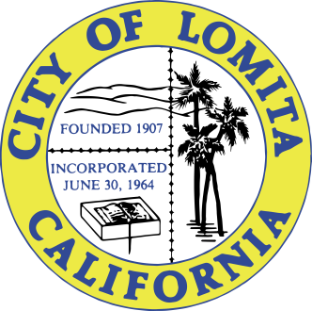

NOTICE OF CANCELLATION
OF THE
PUBLIC SAFETY & TRAFFIC COMMISSION MEETING

NOTICE IS HEREBY GIVEN that the Regular Meeting of the Public Safety & Traffic Commission of the City of Lomita scheduled for Wednesday, August 16, 2023, at 6:00 p.m., has been cancelled due to lack of business.

I, Linda E. Abbott, Deputy City Clerk of the City of Lomita, do hereby certify under penalty of perjury under the laws of the State of California that a full and correct copy of this notice was posted pursuant to Government Code Section 54950 et. seq., at the following locations: Lomita City Hall, 24300 Narbonne Avenue, Lomita Park, 24428 Eshelman Avenue, and uploaded to the City of Lomita website: http://www.lomita.com/cityhall/city_agendas/.

___________________
Linda E. Abbott, Deputy City Clerk

Dated Posted: August 11, 2023

