TENANT IMPROVEMENTS
&
SIGNS

City of Lomita Planning Division 24300 Narbonne Ave. Lomita, CA 90717
Voice: (310) 325-7110 Email: dutyplanner@lomitacity.com

Lomita welcomes new businesses and wants prospective businesses to understand the process to renovate an existing space and install a sign.

To remodel/alter a commercial space within an existing building and to install a new sign, a building permit is needed.

For the Commercial Space:
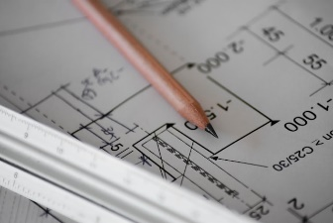
- Submit plans stamped by an architect or engineer are submitted and reviewed first by the Planning Division and then by LA County Building and Safety.
Photo by Sven Mieke

- A permit is issued to a licensed contractor for work shown on the plans, then the work is inspected.

- Then the business can open.

For the Business Sign:
- Submit plans that show the sign’s size and depth, storefront’s height and width, mounting, and electrical features (if any).

- A building sign permit probably is needed.

To Start Go To: https://lomitaca.viewpointcloud.com/

