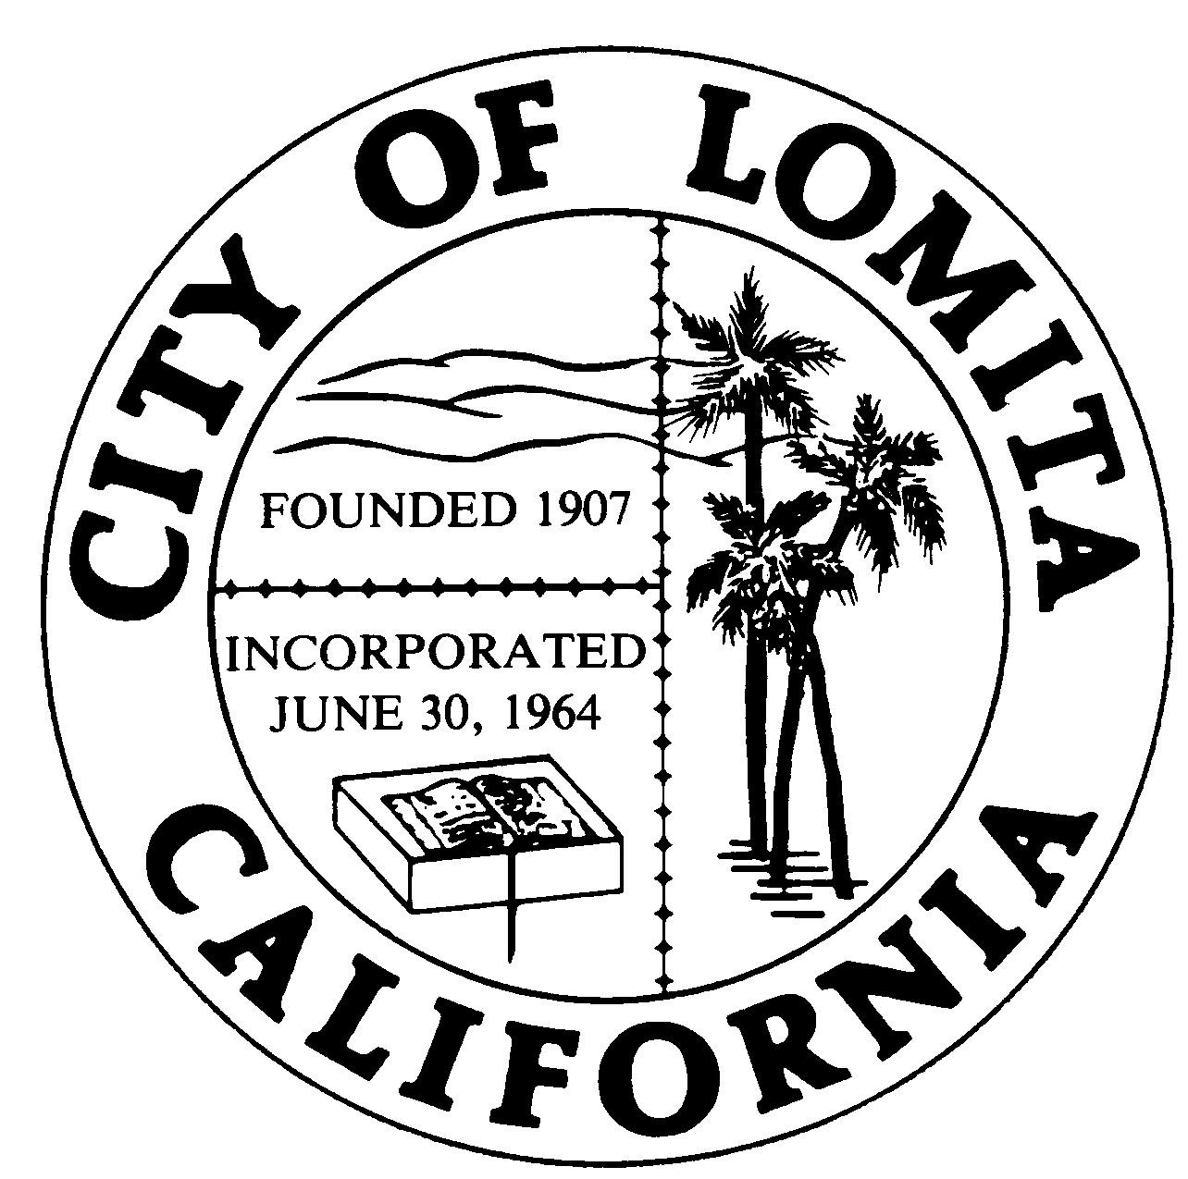
CITY OF LOMITA
CITY COUNCIL REPORT

TO: City Council
Item No. CC 7n

FROM: Ryan Smoot, City Manager

REVIEWED BY: Gary Sugano, Assistant City Manager

Prepared by: Laura MacMorran, Associate Planner

MEETING DATE: April 19, 2022

SUBJECT: Acceptance of the 2021 Annual Progress Reports on the General Plan and Implementation of the Housing Element

RECOMMENDATION

Receive and file the reports.

BACKGROUND

Government Code Section 65400 mandates that by April 1st of each year the local planning agency shall submit a report to the State Office of Planning and Research (OPR) and the Department of Housing and Community Development (HCD) that provides the progress of the implementation of the General Plan and a separate detailed report on housing entitlement and production.

These reports were completed by staff and submitted to OPR and HCD on time, and are attached to this report as Attachment 1 and Attachment 2.

There is not a specific form or format to submit the General Plan Annual Progress Report (APR) and guidelines are intentionally flexible to account for individual circumstances. The purpose of the report is to demonstrate how a city’s activities correspond to the General Plan’s adopted goals, policies and implementation measures. The City’s report features those activities that played a significant role in a city’s implementation of the General Plan for the calendar year.

Unlike the General Plan Annual Progress Report, HCD provides specific forms to complete the Housing Element’s Annual Progress Report to ensure consistency and clarity in the annual reports on the housing element from year to year, and across agencies. Cities must report on each application filed, each permit issued, each dwelling unit demolished and dwelling unit built, and if any special processes were used.
GENERAL PLAN ANNUAL PROGRESS REPORT SUMMARY

Overview
Lomita’s current General Plan was adopted by the City Council on May 4, 1998. The Lomita General Plan contains the seven state-required elements which are land use, circulation, housing, conservation, open space, safety and noise. The State allows the combining of elements or the addition of new elements, as long as the required seven elements are present in some fashion. The City’s General Plan complies with all State mandated requirements. Local governments are required to keep their General Plans current and internally consistent. There is no specific requirement that a local government update its General Plan on a particular timeline, with the exception of the Safety and Housing Elements, which are required to be updated every eight years

2021 General Plan Activity Summaries

Circulation Element Amendment
On July 6th, 2021, the Circulation Element was amended to reclassify Pennsylvania Avenue as a local street instead of a collector street. Low and medium-density housing fronts and surrounds Pennsylvania Avenue and the criteria for a local street were confirmed. This amendment was reviewed and recommended by the Public Safety & Traffic Commission before City Council adopted General Plan Amendment 2021-01 on August 3, 2021.

Safety Element
On December 21, 2021, City Council certified the Initial Study/Mitigated Negative Declaration and adopted General Plan Amendment 2021-02 for an updated 2021-2029 Safety Element. The Goals, Policies, and Actions section provides the City’s safety roadmap with a 20-year horizon. It incorporates and augments mitigation policies contained in the Lomita Hazard Mitigation Plan.

This Safety Element directly relates to topics in the Land Use, Circulation, and Conservation and Open Space Elements of the General Plan. The Safety Element identifies hazards and hazard abatement provisions to guide land use decisions related to zoning, subdivisions, and entitlement permits. The Safety Element also addresses emergency response and evacuation routes, which informs the Circulation Element to ensure that streets are sized adequately for fire truck access and other needs of first responders. This Safety Element also addresses community greening to improve Lomita’s air quality and provide shade on hot days, which correlate with the Conservation and Open Space Element.

Housing Element
On December 21, 2021, City Council certified the Initial Study/Mitigated Negative Declaration and adopted General Plan Amendment 2021-03 for an updated 2021-2029 Housing Element. It provides an analysis of the local housing needs for all income levels, details barriers to providing needed housing, and identifies a set of strategies for meeting the housing need within the planning period.
This updated Housing Element incorporates the programs within the 5th Cycle Housing Element and adds various new programs. Of note are the programs related to rezone of areas where increased density may be appropriate, establishment of procedures and ordinances supportive of affordable housing and specialized opportunities to address housing needs and concerns for populations with special needs..

Public Outreach and Engagement
As the General Plan embodies the community’s values, needs, and vision, the City outreached to all stakeholders and encouraged participation. To ensure that language was not a barrier, all workshops and meetings provided Spanish translation services. To increase participation, the City held two combined Housing Element and Safety Element virtual workshops A community survey was distributed electronically and mailed. City staff manned an information booth at the City’s Farmer’s Market. Separately, the Safety Element Planning Committee held five virtual meetings, the Planning Commission held two virtual hearings and City Council held the final hearing.
The City of Lomita website was redesigned in 2021 to provide a user-friendly and visually appealing website, featuring an intuitive user interface and a flexible back-end that will allow for the site's growth and integration of new technologies. The updated website encourages an open, transparent, and positive communication with the City’s diverse users and ensures public confidence in the City’s local government. Important features include compliance with the American with Disabilities Act (Section 508) and Web Content Accessibility Guidelines, as well as the inclusion of language translation and complete site search capabilities.

Capital Improvement Projects
Capital improvement projects are one measure to evaluate the implementation of the General Plan’s goals and policies. The following notable projects occurred in 2021:

- Upgraded bathroom facilities at Hathaway Park
- The Cypress Water Production Facility is undergoing a multi-year upgrade project
- Street resurfacing and reconstruction
- Narbonne Plaza completed to provide an outdoor seating and venue area in addition to public parking.

Amendments to the Zoning Code
Amendments that impact the City’s orderly growth and development were included in the 2021 Annual Report. Specifically, ZTA 2021-01 (Brewpubs) and ZTA 2021-03 (Self-Storage Facilities) modified existing regulations and furthered the Land Use and Economic Development Elements’ goals.

HOUSING ELEMENT ANNUAL PROGRESS REPORT SUMMARY

For the 5th Cycle Housing Element (2013-2021), the City’s Regional Housing Need Allocation (RHNA) was 47 units. Those units are allocated into income categories. Lomita exceeded the 5th-cycle’s total quota. By income category, the City satisfied all categories, except for very-low income. Without affordability deed restrictions, qualifying units in either the very-low and low-income categories was a challenge.

Unlike past years, the City was able to utilize the Southern California Association of Governments’ 2020 accessory dwelling unit (ADU) rent analysis to determine RHNA income categories. Using SCAG’s evidence-based assumptions for ADU affordability, this year Lomita qualified 17% of ADUs as affordable to extremely and very-low-income households; 43% of ADUs as affordable for low-income households, 6% of ADUs as affordable to moderate income households, and 34% of ADUs as affordable to above-moderate-income households.

2021 Units by Affordability
Income Level | Planning Approval Received | Building Permits Issued | Certificates of Occupancy Issued
Very Low | 3 | 1
Low | 8 |  | 1
Moderate | 3 |  | 1
Above Moderate | 12 | 1 | 5
Total | 30 | 2 | 7

Compared to other years the number of permits issued is extremely low, and it is highly likely that the COVID-19 pandemic hampered construction activities.

For the 5th Cycle Housing Element planning period, the City committed to specific actions to address citywide housing needs and to help achieve housing goals. The programs are aimed to assist in achieving the goals and objectives outlined in the 5th Cycle Housing Element. Throughout 2021, the City continued to provide all the programs outlined in the Housing Element. Many of the Housing Element programs are administered by regional agencies such as the Los Angeles County Development Authority (LACDA) and the City continues to participate in these regional efforts. Regional programs tend to have more funding, and while their success is not often reflected at the local level, the City of Lomita’s residents benefit from these programs. The progress made toward locally administered programs has continued and many have proven to be successful, most notably the accessory dwelling unit program.

The HCD’s annual report forms are attached to this report. They identify the specific properties, as well as the housing programs that the City continues to administer.

ACTION

Receive and file.

FISCAL IMPACT

None.

ATTACHMENTS

- 2021 General Plan Annual Report
- Annual Housing Element Progress Report (HCD Forms)

Reviewed by: Approved by:
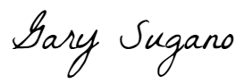
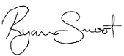

Gary Sugano Ryan Smoot
Assistant City Manager City Manager

Reviewed by: Prepared by:
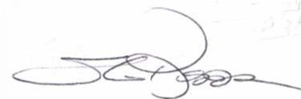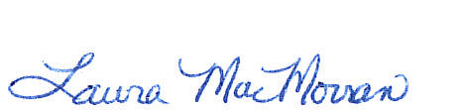
Sheri Repp Loadsman Laura MacMorran
Planner Associate Planner

