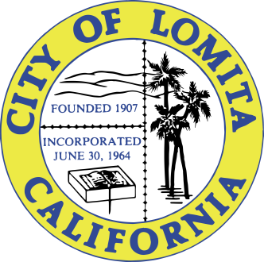

NOTICE OF CANCELLATION OF THE MONDAY, DECEMBER 11, 2023,
MEETING OF THE PLANNING COMMISSION

NOTICE IS HEREBY GIVEN that the Regular Meeting of the Planning Commission of the City of Lomita, scheduled for Monday, December 11, 2023, at 6:00 p.m., has been cancelled due to lack of business.

I, Linda Abbott, Deputy City Clerk of the City of Lomita, do hereby certify under penalty of perjury under the laws of the State of California that a full and correct copy of this notice was posted pursuant to Government Code Section 54950 et. seq., at the following locations: Lomita City Hall, 24300 Narbonne Avenue, Lomita Park, 24428 Eshelman Avenue, and uploaded to the City of Lomita website: https://lomitacity.com/agendas-minutes/.

__________________
Linda Abbott
Deputy City Clerk

Date Posted: December 7, 2023

